|  |  |
| --- | --- |
|  | **FPT ACADEMY INTERNATIONAL**  **FPT – APTECH COMPUTER EDUCATION** |

**Centre Name: ACE-HCMC-2-FPT.**

**Address: 590 Cach Mang Thang 8, District 3, Ho Chi Minh City, Viet Nam.**

**Oni_chan**

|  |  |  |
| --- | --- | --- |
| **Supervisor:** | *LÊ THANH NHÂN* | |
| **Semester:** | *02* | |
| **Batch No:** | T1.1906.M0 | |
| **Group No:** | *02* | |
| **Order:** | **Full name** | **Roll No.** |
| 1. | Nguyễn Quốc Bảo | Student1200864 |
| 2. | Đại Gia Huy | Student1198492 |
| 3. | Nguyễn Minh Huy | Student1204496 |

Month 4 Year 2020

Mục lục

Lời nói đầu

**REVIEW_01**

**Problem Definition (No.01/PD/Ver1.0)**

**1.introduce the topic**

From the past until now, comics, novels, etc. are always loved by people, strongly responding to the field of infinite entertainment, infinite creativity that has a strong influence on life, culture, and need for solving. position, ... of the community. Nowadays, in the era of digital comics, novels, etc. are received more and more quickly and conveniently by comic book, novel websites, etc., becoming indispensable in the field of entertainment. and creativity of everyone.

Because everyone's needs in this area are huge to meet everyone's needs The Oni_chan project is built - an online library of comics and novels. There, people can read and enjoy stories, novels ... unleash creativity to share with people about their self-composed works, comment on the author / novel with their comment, Continuous and accurate updates and quality of comics and novels.

**2. Identify the problem**

+ Provide content of comics, novels, .. to customers

+ Providing information of comics, novels, ... to customers

+ receive customer comments to improve the quality of comics, novels, ..

+ Provide customers with the function of posting, editing their comics and novels

+ Provide administrators with updated information, comic book content, fiction, ...

+ Provide administrator with member management function

**Function:**

+ Registered member customers

+ customers follow comics, novels, ...

+ customers search by name, category, author, ...

+ Customers post and edit their comics and novels

**Customer Requirements Specifications (No.02/CRS/Ver1.0)**

**User:**

**Input:**

* Register account.

• Add manga or novel.

• Feedback for adminitrator.

**Process:**

• Search manga or novel.

• Search by category.

• Check account’s information.

• Check feedback.

**Output:**

• Notification of successful or failed registration.

• Manga or novel by category.

• Information of manga r novel.

• Notification of successful or failed feedback.

**Adminitrator:**

**Input:**

• Data of admin’s login.

• Data of manga or novel to add/modify/delete.

• Data of user’s to modify/delete.

• Feedback of user.

**Process:**

• Add/Modify/Delete manga or novel.

• Modify/Delete information of user.

• Check information of feedback.

**Output:**

• Notification of successful or failed registration.

• Notification of successful or failed of add/modify/delete

manga or novel.

• Notification of successful or failed of modify/delete

information of user.

• Notification of successful or failed of reply feedback.

**Hardware:**

**Sever:**

• Core i5 3230M , 2.6Ghz or better.

• 2 GB of RAM.

• 1GB of HDD capacities available.

**Client:**

• Pentium G4560, 2Ghz.

• 1GB of RAM.

**Software:**

**Sever:**

• OS with Windows XP SP2

• IE 5.0/Netcape 6.0

• MySQL Server

• Dreamweaver MX 2004

• Internet information Services (IIS)

**Client:**

• IE 5.0/ Netscape 6.0

• Flash player 8

**REVIEW_02**

**A.Data Flow Diagram (No.03/DFD/Ver1.0)**

Data Flow Diagram:

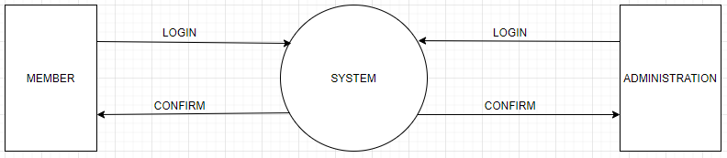

**B.Entity Relationship Diagram (No.04/ERD/Ver1.0)**

Entity Relationship Diagram:

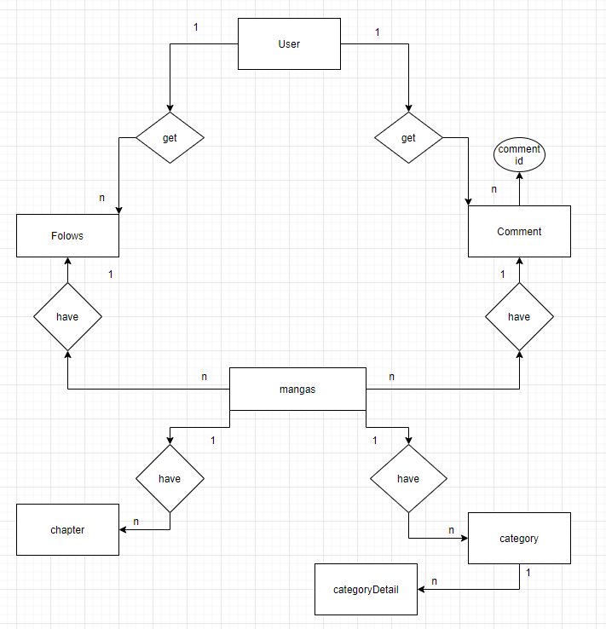

User:

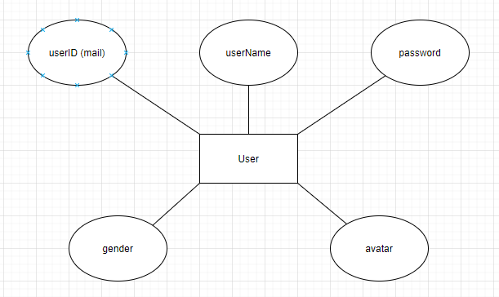

Admin:

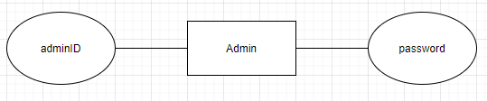

Manga:

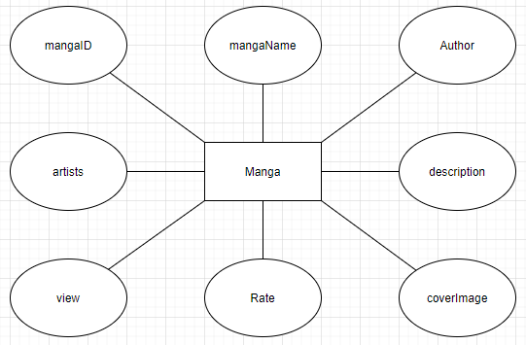

Comment:

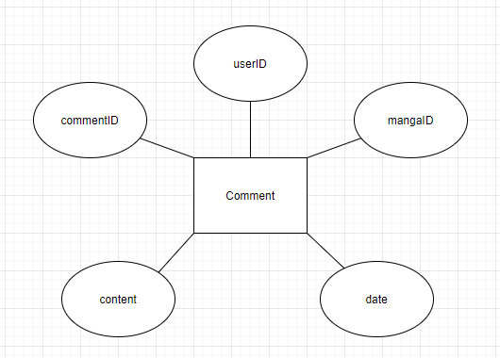

Folow:

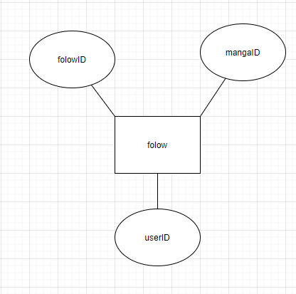

Chapter:

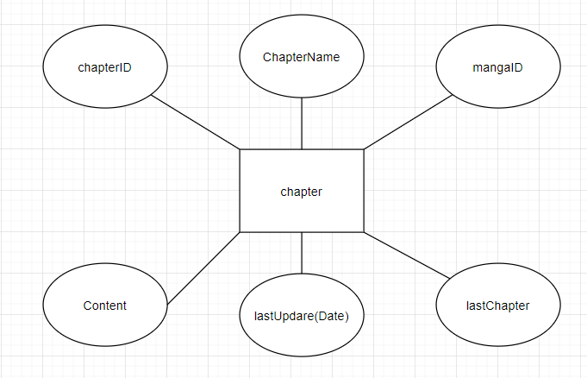

Category:

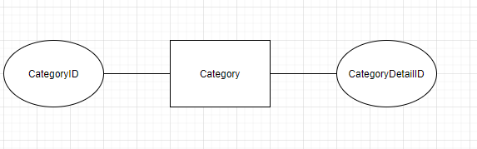

Category Detail:

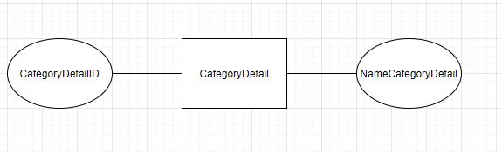

**C.Table Design:**

**Admin:**

|  |  |  |  |  |  |
| --- | --- | --- | --- | --- | --- |
| stt | Column Name | Data type | Keys | Constraints | Depcription |
| 1 | admin | Varchar (100) | Primary Key | Not null |  |
| 2 | password | Varchar (100) |  | Not null |  |

**User:**

|  |  |  |  |  |  |
| --- | --- | --- | --- | --- | --- |
| stt | Column Name | Data type | Keys | Constraints | Depcription |
| 1 | userID | Varchar (100) | Primary Key | Not null |  |
| 2 | password | Varchar (100) |  | Not null |  |
| 3 | userName | Varchar (100) |  | Not null |  |
| 4 | avatar | Varchar (100) |  | Not null |  |
| 5 | gender | Boolean |  | Not null |  |

**Comment:**

|  |  |  |  |  |  |
| --- | --- | --- | --- | --- | --- |
| stt | Column Name | Data type | Keys | Constraints | Depcription |
| 1 | commmentID | Varchar (100) | Primary Key | Not null |  |
| 2 | userID | Varchar (100) | Foreign Key | Not null |  |
| 3 | mangaID | Varchar (100) | Foreign Key | Not null |  |
| 4 | content | Varchar (300) |  | Not null |  |
| 5 | date | Date |  | Not null |  |

**Follow:**

|  |  |  |  |  |  |
| --- | --- | --- | --- | --- | --- |
| stt | Column Name | Data type | Keys | Constraints | Depcription |
| 1 | followID | Varchar (100) | Primary Key | Not null |  |
| 2 | userID | Varchar (100) | Foreign Key | Not null |  |
| 3 | mangaID | Varchar (100) | Foreign Key | Not null |  |

**Manga:**

|  |  |  |  |  |  |
| --- | --- | --- | --- | --- | --- |
| stt | Column Name | Data type | Keys | Constraints | Depcription |
| 1 | mangaID | Varchar (100) | Primary Key | Not null |  |
| 2 | mangaName | Varchar (100) |  | Not null |  |
| 3 | author | Varchar (100) |  | Not null |  |
| 4 | artsits | Varchar (100) |  | Not null |  |
| 5 | description | Varchar (300) |  | Not null |  |
| 6 | view | Int(11) |  | Not null |  |
| 7 | rate | Int(11) |  | Not null |  |
| 8 | coverImage | Varchar (300) |  | Not null |  |

**Chapter:**

|  |  |  |  |  |  |
| --- | --- | --- | --- | --- | --- |
| stt | Column Name | Data type | Keys | Constraints | Depcription |
| 1 | chapterID | Varchar (100) | Primary Key | Not null |  |
| 2 | chapterName | Varchar (100) |  | Not null |  |
| 3 | mangaID | Varchar (100) | Foreign Key | Not null |  |
| 4 | content | Varchar (100) |  | Not null |  |
| 5 | view | Int(11) |  | Not null |  |
| 6 | lastUpdate | Int(11) |  | Not null |  |
| 7 | lastChater |  |  |  |  |

**Category:**

|  |  |  |  |  |  |
| --- | --- | --- | --- | --- | --- |
| stt | Column Name | Data type | Keys | Constraints | Depcription |
| 1 | categoryID | Varchar (100) | Primary Key | Not null |  |
| 2 | mangaID | Varchar (100) | Foreign Key | Not null |  |

**Categorydetail:**

|  |  |  |  |  |  |
| --- | --- | --- | --- | --- | --- |
| stt | Column Name | Data type | Keys | Constraints | Depcription |
| 1 | categoryDetailID | Varchar (100) | Primary Key | Not null |  |
| 2 | categoryID | Varchar (100) | Foreign Key | Not null |  |
| 3 | categotyName | Varcahr (100) |  | Not null |  |

**Relatetionship Diagram:**

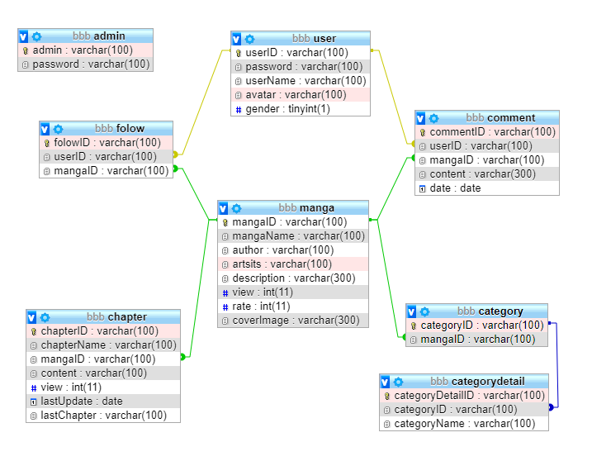

**D.Sitemap:**

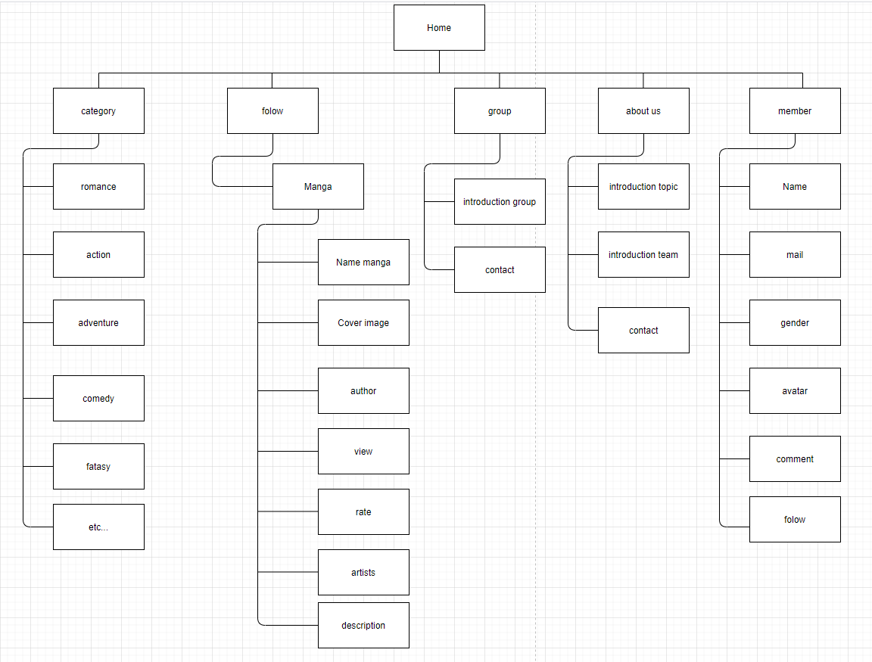

**E. Algorithm(No.06/Al/Ver1.0)**

